 SSIP Cell

Date: 20/02/2025
Report: STUDENT SENSITIZATION PROGRAM – Health Perspective
SSIP 2.0 Awareness Program – Health Perspective
Date: 20th February 2025
Expert: Dr. Hafiza Malik
Duration: 2 Hours
On 20th February 2025, a specialized SSIP 2.0 (Student Startup and Innovation Policy) Awareness Program was organized, focusing on promoting innovation and entrepreneurship in the field of alternative and holistic healthcare. The session was primarily aimed at Homoeopathy, BPT (Physiotherapy) students, offering them a comprehensive understanding of how SSIP 2.0 can be a powerful platform for translating healthcare ideas into impactful startups.
The session was led by Dr. Hafiza Malik, who provided valuable insights into how SSIP 2.0 can be effectively utilized across these domains. She explained how Homoeopathy students can explore innovative projects such as teleconsultation platforms, AI-based symptom analysis tools, digital case record systems, and mobile apps for remedy selection and dosage tracking.
Incorporating the BPT perspective, Dr. Hafiza Malik highlighted opportunities for physiotherapy students to develop digital physiotherapy assessment tools, rehabilitation tracking apps, wearable devices for posture and mobility monitoring, and virtual therapy platforms to extend physiotherapy services to remote populations. The integration of technology and personalized therapy plans was encouraged to enhance patient compliance and outcomes.
Throughout the session, the importance of evidence-based practices, technological integration, and patient-centric innovation was underscored. Students were encouraged to identify unmet healthcare needs in their respective fields and create affordable, user-friendly solutions that bridge traditional and modern medical practices.
SSIP 2.0 offers substantial support in the form of funding, expert mentorship, incubation facilities, and research collaboration opportunities to empower students from these diverse healthcare disciplines to turn their ideas into viable medical startups.
This awareness session successfully broadened the vision of participants, inspiring them to apply their academic and clinical knowledge to solve real-world healthcare challenges. It served as a catalyst for fostering interdisciplinary collaboration and nurturing a new generation of innovators dedicated to shaping the future of integrative and holistic healthcare.
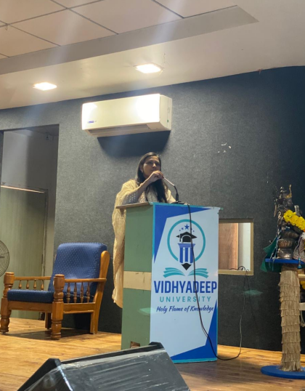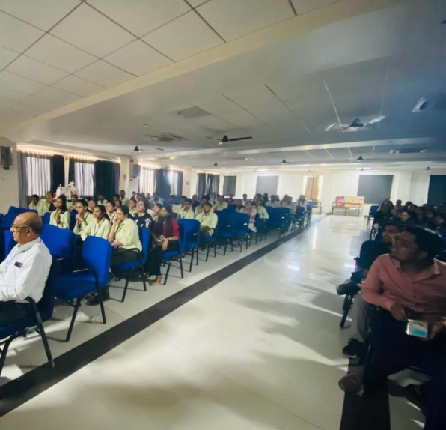

SSIP Coordinator
Vidhyadeep University

